Q1. Which software development technique is good for systems that have third-party API calls, cron jobs, data exports/imports, etc.?
Ans
For systems involving third-party API calls, cron jobs, and data imports/exports, Test-Driven Development (TDD) combined with Modular Frameworks is the best approach.
TDD ensures robust code by writing tests before implementation, which is vital for API calls and data processes.
Modular Frameworks organize code into reusable modules, making it easier to maintain, debug, and adapt.
Integrate with Test Automation to handle regression and ensure smooth execution of scheduled jobs.
This approach minimizes errors, ensures compatibility, and supports scalability.
Q2. Where does Test Automation fit in the Software Life Cycle? Explain with a diagram.
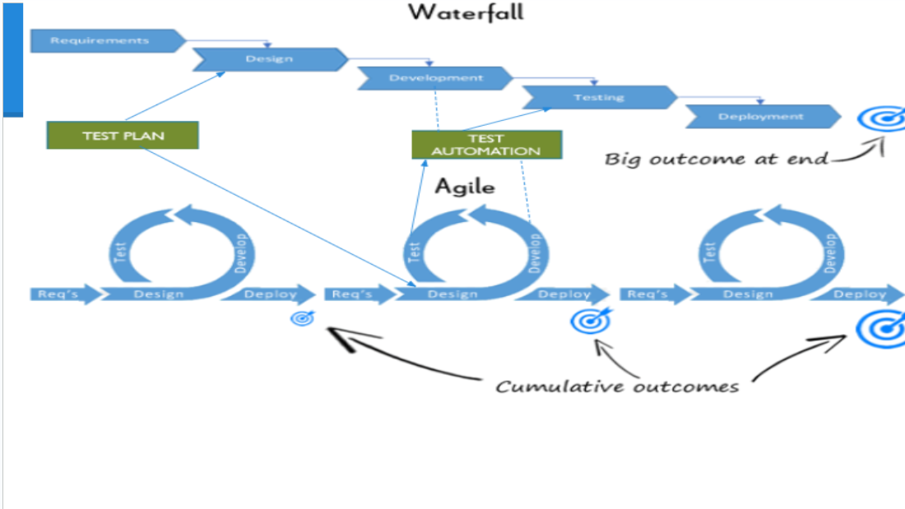
Ans
Test Automation fits into various stages of the Software Development Life Cycle (SDLC):
Requirement Analysis: Test automation frameworks are selected.
Design and Development: Automated test cases are written.
Testing Phase: Automation is used for regression and performance tests.
Maintenance Phase: Automated scripts are updated to adapt to changes.
Diagram:
Q3. Can we skip the manual testing, and why?
Ans.
No, manual testing cannot be skipped.
Automated testing is great for repetitive, scripted tasks like regression testing but lacks the human intuition needed to discover new or unexpected defects.
Manual testing focuses on exploratory testing, which is essential for identifying issues that automation might miss.

Q4. Give the names of the selectors (locators).
Ans.
XPath
CSS Selectors
Both are vital for web testing to locate elements within a web page.
Q5. What is the modular framework?
Ans.
A modular framework divides the test scripts into small, independent modules.
Each module represents a specific functionality of the application.
These modules can be reused, making the framework scalable and maintainable.
Q6. Explain the Open Source tool.
Ans.
Open-source tools:
Offer a large variety of options (e.g., Selenium, JMeter).
Many are free and customizable.
They are sustainable and unlikely to be discontinued.
They integrate well with other tools.
However, the quality varies, and some tools may not be as good as others.
Q7. What is a Hybrid framework?
Ans.
A Hybrid framework combines features of multiple frameworks, such as:
Data-Driven: For managing test data.
Keyword-Driven: For creating test cases using keywords.
Modular: For dividing tests into reusable modules.
This ensures flexibility, scalability, and better maintenance.
Q8. Write a name of a record and replay tool.
Ans.
Selenium IDE is a record-and-replay tool.
Q9. What is the difference between BDD and Cucumber?
Ans.
BDD (Behavior-Driven Development):
A development methodology where test cases are written in plain English to describe the expected behavior of the system.
Cucumber:
A tool that supports BDD by converting plain English text (written in Gherkin syntax) into executable test scripts.
Q10. Can we replace manual regression testing with test automation, and how?
Ans.
Yes, manual regression testing can be replaced with test automation:
Automated tools execute regression tests efficiently and repeatedly without human intervention.
This reduces effort and time while increasing accuracy.
However, automation is not suitable for exploratory or new feature testing, where human insight is needed.
Q11. How many ‘A’s does a test script have? Explain them.
Ans.
A test script typically has three 'A's:
Arrange: Set up test data and environment.
Act: Perform the actions to test the functionality.
Assert: Validate the outcome against the expected result.
These steps form the core structure of a test case.

